RECOMMENDATIONS FOR AUTHORS

- REQUIREMENTS FOR ARTICLE STRUCTURE AND CONTENT

The requirements for the structure and content of the article correspond to the provisions of the National Standard of Ukraine DSTU 7152:2020 and the Recommendations of EASE (European Association of Science Editors).

The structural elements of the article include:
- UDC Index
- Digital Object Identifier (DOI)
- Information about the author(s)
- Article Title
- Abstract
- Keywords
- Main text of the article
- Author contribution information
- Acknowledgments, funding sources
- References
- Dates of submission, review, and approval for publication
- Translation of author information, title, abstract, keywords (if applicable)

1. UDC Index

The UDC index is placed in the upper left corner of the page.

If you have a problem determining the UDC index of your article, write to us at the editorial office, indicating your name, surname, position, and title of the article.

2. DIGITAL OBJECT IDENTIFIER (DOI)
The DOI (Digital Object Identifier) must be placed on a separate line below the UDC index. The DOI is assigned by the journal's founder and publisher (registered by the Department of Information Technology and Computer Support of the M. Maksymovych Scientific Library).
PLEASE NOTE: Authors DO NOT contact the M. Maksymovych Scientific Library regarding DOI assignment. All communication with the Department of Information Technology and Computer Support is handled exclusively by the Editorial Board.

3. AUTHOR INFORMATION
The order of authors must be determined prior to manuscript submission (see "Authorship and Co-authorship" link to the editorial policy section). Any changes made after the manuscript has been submitted must be approved by all authors.
The author information section must include the following elements:
- First name and last name;
- Academic degree and academic title;
- ORCID ID (unique researcher identifier);
- Institutional (corporate) email address;
- Primary affiliation at the time of the study (name of the institution or organization), city, and country.
Authors must state their affiliation exactly as it appears on the institution's official website. Please use your official corporate email address for all communication with the journal’s editorial office.
Please use abbreviations for academic degrees, academic titles, and positions in Ukrainian and English according to Table 1.

Table 1.
Abbreviations of Academic Degrees, Titles, and Positions

English | Ukrainian
Academic Ranks
Active Member of the National Academy of Sciences of Ukraine | акад. НАН України
Corresponding Member of the National Academy of Sciences of Ukraine | чл.-кор. НАН України
Academic Degrees
DSc (…) | д-р (…) наук
DSc (Geol. & Mineral.) | д-р геол.-мінерал. наук
DSc(Geol.) | д-р геол. наук
DSc (Geogr.) | д-р геогр. наук
DSc(Engin.) | д-р техн. наук
DSc (Biol.) | д-р біол. наук
DSc (Phys. &Math.) | д-р фіз.-мат. наук
PhD (…) | канд. (…) наук
PhD (Geol. &Mineral.) | канд. геол.-мінерал. наук
PhD (Geol.) | канд. геол. наук
PhD (Geogr.) | канд. геогр. наук
PhD (Engin.) | канд. техн. наук
PhD (Biol.) | канд. біол. наук
PhD (Phys. &Math.) | канд. фіз.-мат. наук
PhD | д-р філософії
Academic Titles
Prof. | проф.
Assoc. Prof. | доц.
DoctoralStudent | докторант
Assist. | асист.
Senior Researcher | ст. наук. співроб.
Senior Researcher | ст. дослідник
Junior Researcher | мол. наук. співроб.
Researcher | наук. співроб.
PhD Student | асп.
PhD Student | ад'юнкт
Student | студ.
Bachelor | бакалавр
Master's Student | магістр (який/а вчиться)
Master of Arts | магістр (який/а захистив/ла диплом)
Senior Lecturer | ст. викл.
Lecturer | викл.
Leading Researcher | провід. наук. співроб.
Principal Researcher | голов. наук. співроб.
Leading Engineer | провід. інж.
Engineer | інж.

4. ARTICLE TITLE
The title must be unambiguous, clear to specialists in other fields, informative, and specific. It should contain 5–9 words that accurately reflect the article's content, avoiding vague phrases such as "Research on...", "Some issues of...", "Problems of...", etc.
For original research articles, it is recommended to include a study descriptor in the title, such as "a cross-sectional study," "a practical study," or "survey results" (for more details, see the title requirements in the EASE Guidelines (European Association of Science Editors) for Authors and Translators of Scientific Articles to be Published in English).

PLEASE NOTE: Authors must submit two versions of their manuscript: 1) A version containing author information (file name: "Authors. Article Title"). 2) A version without author information (file name: "For Review. Article Title"). This is required to ensure a double-blind peer review process. The 'For Review' file must be completely anonymized.

5. ABSTRACT
The abstract must reflect the content of the article, as for most readers, it will be the primary source of information about the study (many databases index only the title and the abstract).

The abstract for an original research article must be structured and informative, containing the following sections:
- Background (context, relevance, and aim of the study).
- Methods.
- Results.
- Сonclusions.
Refer to the sample abstract in Appendix 1 and the abstract requirements in the EASE Guidelines (European Association of Science Editors).

Length: The abstract should be between 1,800 and 2,500 characters (including spaces).

6. KEYWORDS
For an original research article: 4–8 keywords.
Keywords should not repeat words already used in the title.

7. MAIN BODY OF THE ARTICLE
Word Count:
- Original research article: from 3,000 to 8,000 words (up to 50,000 characters).
Article Structure: An original research article must follow the IMRAD structure and include the following core elements:
- Background (context, relevance, aim, and objectives of the study).
- Methods.
- Results.
- Discussion and Conclusions.
Detailed requirements for each structural element are provided in the EASE Guidelines for authors and translators of scientific articles.

Illustrations and Tables: All figures (schemes, graphs, diagrams, etc.) and tables must be numbered with Arabic numerals and placed directly within the text where they are contextually relevant (not at the end of the document).
- Figures require explanatory captions (placed below the figure in a separate paragraph).
- Tables require thematic titles (placed above the table in a separate paragraph). Captions and titles must accurately reflect the content, being both concise and informative. Every figure or table must be cited within the main text by its sequence number: (Table 1), (Fig. 1).

Example:

Table 1
Ecological features of mass species of blood-sucking mosquitoes of the Pyryatyn district

A type of mosquito | By type of biotope development |  | At the scene of the attack |  | By characteristics of sexual behavior |  | By the breadwinners
A type of mosquito | eurytopic | stenotopic | exophilic | endophilic | eurygamous | stenogamous | А | М | Н
Ae. cinereus | + | – | + | – | + | – | – | + | ++
Cx. modestus | + | – | ++ | – | + | – | – | + | ++
Ae. vexans | + | – | ++ | + | + | – | – | + | ++
Note: A – birds; M – mammals; H – humans; – – no; ++ – mostly, yes; + – usually, yes.
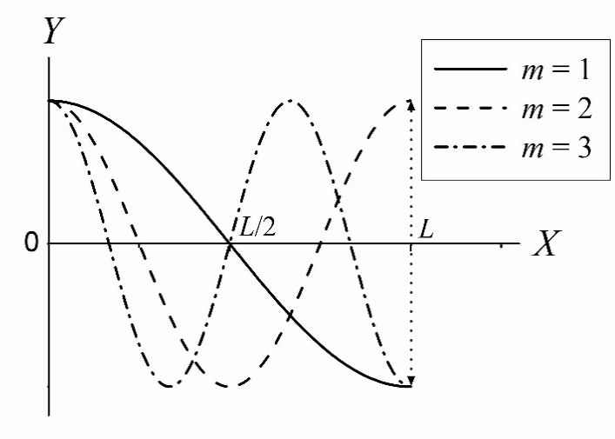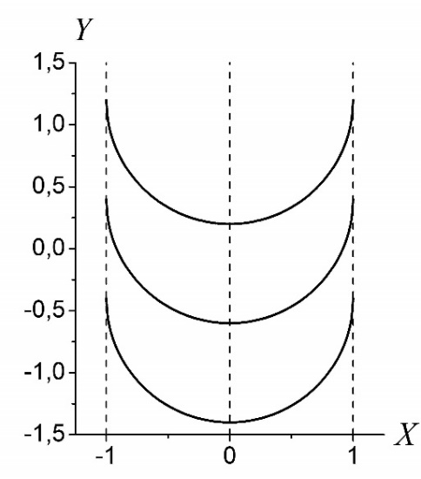
Fig. 1. Eigenfunctions of a boundary value problem with homogeneous conditions of the 2nd kind | Fig. 2. Integral Curve Equations

If the article is accepted, authors upload separate high-resolution files of all figures in .tif or .jpg formats. File names for infographics should be clear and consistent with the names in the text (e.g., Figure 1, Figure 2). Image resolution: 1200 dpi for line art, 600 dpi for grayscale, and 300 dpi for color.

8. INFORMATION ABOUT THE AUTHORS' CONTRIBUTION

It is necessary to indicate information about the contribution of the authors to the preparation of the article in accordance with CRediT (Contributor Roles Taxonomy):
- Conceptualization. Ideas; formulation or evolution of overarching research goals and aims.
- Formal Analysis. Application of statistical, mathematical, computational, or other formal techniques to analyze or synthesize study data.
- Software. Programming, software development; designing computer programs; implementation of the computer code and supporting algorithms; testing of existing code components.
- Methodology. Development or design of methodology; creation of models.
- Data Validation. Verification, whether as a part of the activity or separate, of the overall replication/reproducibility of results/experiments and other research outputs.
- Writing – Original Draft. Preparation, creation, and/or presentation of the published work, specifically writing the initial draft (including substantive translation).
- Writing – Review & Editing. Preparation, creation, and/or presentation of the published work by those from the original research group, specifically critical review, commentary, or revision — including pre- or post-publication stages.

Example:
Author Contributions: Firstname Lastname — conceptualization, methodology; Firstname Lastname — software, formal analysis; Firstname Lastname — data validation, writing – original draft; Firstname Lastname — writing – review & editing.

9. ACKNOWLEDGEMENTS AND FUNDING SOURCES

Acknowledgements: Mention all individuals who made a significant contribution to the study but do not meet the criteria for authorship. This includes those who coordinated research activities or provided resources (e.g., research materials, reagents, laboratory samples, animals, equipment, computing resources, or other analytical tools).
Funding: All sources of funding must be disclosed. Authors are required to clearly state the funding source for the research or the preparation of the article in the metadata.
- Recommended format: "This work was supported by the Medical Research Council (grant number xxxx)."
IMPORTANT NOTICE!
- If there was no external funding, the following statement must be included:
"This study did not receive any grant from a funding institution in the public, commercial, or non-commercial sectors."
- If the research is funded by a higher education institution or other organizations, this must also be specified.
Example: "This research was conducted without external grant funding, as part of the core scientific activities of Taras Shevchenko National University of Kyiv."

10. REFERENCES AND IN-TEXT CITATIONS

Reference List Requirements
According to the APA 7th Edition guidelines, there are specific rules for listing authors in the References section:
- Up to 20 authors: You must provide the surnames and initials of all authors. The abbreviation "et al." should not be used in the reference list for sources with 20 or fewer authors. An ampersand (&) is placed before the final author's name.
- 21 authors or more: List the first 19 authors, followed by an ellipsis (...), and then the surname and initials of the final author from the original list.
IMPORTANT NOTICE!
Please ensure you verify the full list of authors for all cited works. In the reference list, the use of "et al." is replaced by the "19 authors + ellipsis + final author" format only when the total number of authors exceeds 20.

- Original Language List: Bibliographic descriptions must follow the APA Style (7th Edition).

- References in English: For sources in non-Roman scripts (e.g., Cyrillic, Arabic, Chinese), provide an English translation of the entry, followed by the original language in square brackets at the end: [in Ukrainian], [in Chinese], etc.
- Latin-script Sources: Sources originally written in Latin-based scripts (e.g., Polish, German, Spanish) remain untranslated.
Examples:
Zhenchenko, M. (2023). Digital transformation of the publishing industry. Zhnets [in Ukrainian].
Bartmiński, J. (2026). Językowe podstawy obrazu świata. Wydawnictwo Uniwersytetu Marii Curie-Skłodowskiej.

In-text Citation Format
In-text citations must be placed in parentheses and formatted as follows:
- Single Author or Title: Include the author's last name (or the first few words of the title for works with no author), followed by a comma and the year of publication. Use "p." (singular) or "pp." (plural) for page numbers. Titles may be shortened using an ellipsis (...): (Freeberg, 2021), (Freeberg, 2021, p. 147), (Freeberg, 2021, pp. 56–57), (Scientific Heritage..., 2026, p. 45).
- Two to Three Authors: List the last names of all authors and the year: (Cornell & Harlow, 2023), (Dormus, Brown, & Bloom, 2023).
- More than Three Authors: List only the first author's last name followed by "et al." and the year: (Grady et al., 2024), (Nazarenko et al., 2022).
- Authors with the Same Last Name: Include the author's initials if citing different authors with the same surname published in the same year: (Reinberg, T., 2025).
- Multiple Works by the Same Author: * Different years: Do not repeat the name; separate years with a semicolon: (Gibson, 2020, p. 115; 2021, pp. 73–75).
  - Same year: Use lowercase Latin letters (a, b, c) after the year: (Gibson, 2025a; 2025b).
- Electronic Sources without Page Numbers: Indicate the part, volume, or section number: (Brown, 2021, vol. 2).
- Multiple Sources in One Citation: List sources in alphabetical order, separated by semicolons: (Freeberg, 2021; Grady et al., 2021).

Citation and Reference Quality Standards:
- Source Recency: The majority of citations (75%) must be from authoritative sources published within the last 5 years.
- Database Indexing: At least 30% of the reference list must consist of articles published in high-ranking journals indexed in the Scopus and Web of Science scientometric databases.
- Self-citation: Self-citation must not exceed 15% of the total number of cited sources.

EXAMPLES OF BIBLIOGRAPHIC DESCRIPTIONS (APA Style, 7th Edition)

Book
Author, A. A. (Year). Title of the book. Publisher.
- Covey, S. R. (2013). The 7 habits of highly effective people: Powerful lessons in personal change. Simon & Schuster.
- Svendsen, S., & Løber, L. (2020). The big picture/Academic writing: The one-hour guide (3rd digital ed.). Hans Reitzel Forlag. https://thebigpicture-academicwriting.digi.hansreitzel.dk/
- Brück, M. (2009). Women in early British and Irish astronomy: Stars and satellites. Springer Nature. https://doi.org/10.1007/978-90-481-2473-2
- Zhenchenko, M. (2019). Digital transformations of the publishing industry (2nd ed.). Zhnets. https://www.zhnets.com.ua/zhenchenko-maryna-tsyfrovi-transformatsiyi-vydavnychoyi-galuzi-kyyiv-zhnets-2019-2-ge-vyd-zmin-409-s/ [in Ukrainian]

Journal Article
Author, A. A. (Year). Title of the article. Title of the Journal, Volume(Issue), Pages. URL/DOI
- Grady, J. S., Her, M., Moreno, G., Perez, C., & Yelinek, J. (2019). Emotions in storybooks: A comparison of storybooks that represent ethnic and racial groups in the United States. Psychology of Popular Media Culture, 8(3), 207–217. https://doi.org/10.1037/ppm0000185

Conference Presentation
Author, A. A. (Year, Month Days). Title of presentation [Conference presentation]. Name of Conference, Location. URL
- Evans, A. C., Jr., Garbarino, J., Bocanegra, E., Kinscherff, R. T., & Márquez-Greene, N. (2019, August 8–11). Gun violence: An event on the power of community [Conference presentation]. APA 2019 Convention, Chicago, IL, United States. https://convention.apa.org/2019-video

Conference Proceedings (Published in a book/series)
Author, A. A. (Year). Title of contribution. In Editor(s) (Eds.), Title of Conference: Vol. Number. Title of book (pp. xxx–xxx). Publisher. URL/DOI
- Bedenel, A.-L., Jourdan, L., & Biernacki, C. (2019). Probability estimation by an adapted genetic algorithm in web insurance. In R. Battiti, M. Brunato, I. Kotsireas, & P. Pardalos (Eds.), Lecture notes in computer science: Vol. 11353. Learning and intelligent optimization (pp. 225–240). Springer. https://doi.org/10.1007/978-3-030-05348-2_21

Dissertations & Thesis
- Published:
  - Moss, C. L. (2025). Expanded internet art and the informational milieu (Publication No. 3740855) [Doctoral dissertation, New York University]. PQDT Open. https://pqdtopen.proquest.com/doc/1753118023.html?FMT=AI
- Unpublished:
  - Harris, L. (2024). Instructional leadership perceptions and practices of elementary school leaders [Unpublished doctoral dissertation]. University of Virginia.

Legal Acts & Standards
- Law on Ensuring the Functioning of Ukrainian as the State Language. (2019). Law of Ukraine dated 25.04.19. № 2704-VIII. https://zakon.rada.gov.ua/laws/show/2704-19 [in Ukrainian]
- International Organization for Standardization. (2018). Occupational health and safety management systems – Requirements with guidance for use (ISO Standard No. 45001:2018). https://www.iso.org/standard/63787.html

Additional Resources
For more detailed information, please refer to the Publication Manual of the American Psychological Association (7th ed.) or use automated citation tools such as Grafiati or Zotero.

11. INFORMATION ON SUBMISSION AND EDITORIAL PROCESSING DATES

At the end of the article, provide the information in the following format:
Отримано редакцією журналу / Received:
Прорецензовано / Revised:
Схвалено до друку / Accepted:

12. TRANSLATION OF AUTHOR(S) INFORMATION, ARTICLE TITLE, ABSTRACT, AND KEYWORDS

For articles written in English, translated Ukrainian metadata (article title, author(s) information, abstract of at least 1800 characters, and keywords) should be placed at the very end of the article, after the reference list and submission date.

At the end of each article, after the translated title, author(s), abstract, and keywords, the following mandatory text should be included:

FOR A SINGLE AUTHOR
The author declares no conflicts of interest. The funders had no role in the design of the study; in the collection, analyses or interpretation of data; in the writing of the manuscript; in the decision to publish the results.
Автор заявляє про відсутність конфлікту інтересів. Спонсори не брали участі в розробленні дослідження; у зборі, аналізі чи інтерпретації даних; у написанні рукопису; в рішенні про публікацію результатів.

FOR TWO OR MORE AUTHORS
The authors declare no conflicts of interest. The funders had no role in the design of the study; in the collection, analyses or interpretation of data; in the writing of the manuscript; in the decision to publish the results.
Автори заявляють про відсутність конфлікту інтересів. Спонсори не брали участі в розробленні дослідження; у зборі, аналізі чи інтерпретації даних; у написанні рукопису; в рішенні про публікацію результатів.

- Technical Formatting Requirements

The technical formatting of the manuscript must comply with the standards of the Publishing and Printing Center of Taras Shevchenko National University of Kyiv, specifically:

1. File Format The text must be submitted as a WinWord file (*.doc, *.docx) without the use of style sheets or custom style tagging.

2. Page Layout Parameters
- Line spacing: Single;
- Paragraph indent (first line): 0.5 cm;
- Page size: A4;
- Margins:
Top | 2,5 | Bottom | 2,5
Left | 1,8 | Right | 1,8
From edge to header |  |  | 1,7
From edge to footer |  |  | 1,7

3. Formatting Parameters for Structural Elements:
- UDC Index — Arial, 8 pt, bold;
- DOI Index — Arial, 8 pt, bold;
- Author Information — Arial, 8 pt, bold;
- Article Title — Arial Black, 10 pt, bold, ALL CAPS;
- Abstract (in Ukrainian and English) — Arial, 8 pt, italics;
- Structured Abstract Headings ("Background", "Methods"...) — Arial, 8 pt, bold, expanded spacing 2 pt;
- Main Body Text — Arial, 9 pt, regular;
- Tables (titles and data) and Figures (labels and captions) — Arial, 8 pt;
- Author Contributions — Arial, 8 pt, regular;
- Acknowledgements and Funding Sources — Arial, 8 pt, regular;
- References — Arial, 7 pt, regular;
- Submission and Processing Dates — Arial, 7 pt, bold, expanded spacing 1 pt.

4. Additional Text Requirements:
- Abbreviations: Each abbreviation must be introduced in parentheses after its first mention in full; thereafter, only the abbreviation should be used.
- Quotations: All quotations must be presented in the language of the article (regardless of the original language) and must be accompanied by a citation including the source and specific page number.
- Citations and References: All entries in the reference list must be cited in the text; conversely, all citations within the text must be included in the reference list.
- Omissions in Quotes: Any omitted text within a quotation should be indicated by square brackets with an ellipsis: […].
- Formulas: Mathematical formulas must be created using a formula editor (Microsoft Equation or MathType) or the Microsoft Office Equation tool. The font size for formulas should be 10 pt.
- Units of Measurement: Use a non-breaking space (Ctrl+Shift+Space) between a numerical value and its unit of measurement.
- Punctuation and Symbols: Adhere to the following formatting for symbols:
  - Use straight or "smart" quotation marks as per house style (e.g., "...").
  - Use the correct apostrophe (').
  - Use an en-dash (–) for punctuation, not an em-dash (—) or a hyphen (-).
- Ranges: Use an en-dash to indicate ranges (from... to...): e.g., pp. 95–97, the 30s–40s, April–May, Kyiv–Lviv.
- Character Accuracy: Do not substitute Latin characters with Cyrillic ones or vice versa (e.g., Latin o, a, c, x, p, e, H, T, I, M, B instead of Cyrillic о, а, с, х, р, е, Н, Т, І, М, В). This is critical for the author’s name, article title, abstract, keywords, and references, as incorrect characters will cause indexing errors and prevent the publication from being identified in search and bibliometric databases.

Appendix 1

Sample Formatted Article
UDK 159.923:159.952
DOI:
Nataliia STENIAKINA, Student
ORCID ID: 0009-0005-2419-8255
e-mail: steniakina_nataliia@knu.ua
Taras Shevchenko National University of Kyiv, Kyiv, Ukraine

Tetiana BABICH, PhD (Biol.), Assist.
ORCID ID: 0000-0001-9500-6437
e-mail: babich_tetiana@knu.ua
Taras Shevchenko National University of Kyiv, Kyiv, Ukraine

Yuliia YUMYNA, PhD (Biol.), Assoc. Prof.
ORCID ID: 0000-0002-4568-1415
e-mail: juliayumyna@knu.ua
Taras Shevchenko National University of Kyiv, Kyiv, Ukraine

MICROORGANISM-DEPENDENT PHAGOCYTIC RESPONSES IN MURINE ALVEOLAR MACROPHAGES

Background. Macrophages are a highly heterogeneous immune cell subset that play essential roles in innate and adaptive immunity. Alveolar macrophages (AMs) represent the major resident immune cell population in the distal airways and constitute the first line of cellular defense against inhaled microorganisms. Phagocytosis is a fundamental function of AMs, supporting both pathogen clearance and lung homeostasis. However, the efficiency with which AMs internalize different classes of microorganisms remains incompletely explored, despite its relevance for early host–pathogen interactions in the lung. This study aimed to quantitatively compare the phagocytic activity of murine alveolar macrophages toward Gram-negative bacteria (Escherichia coli), Gram-positive bacteria (Staphylococcus aureus), and the yeast Candida albicans under non-opsonized, non-inflammatory in vitro conditions using flow cytometry.
Methods. Murine AMs were isolated from BALB/c mice by bronchoalveolar lavage. Phagocytic activity was assessed using FITC-labeled, inactivated microorganisms, including heat-killed Staphylococcus aureus (Gram-positive), heat-killed Escherichia coli (Gram-negative), and ethanol-fixed Candida albicans. AMs were incubated with microbial targets for 30 minutes at 37 °C. Phagocytosis was quantified by flow cytometry as the percentage of FITC-positive cells and the phagocytic index, expressed as mean fluorescence intensity.
Results. Analysis of AM phagocytic activity revealed pronounced target-dependent differences. Uptake was lowest for Escherichia coli, intermediate for Staphylococcus aureus, and highest for Candida albicans. This pattern was consistent for both the percentage of phagocytosing cells and the phagocytic index.
Conclusions. Taken together, murine alveolar macrophages exhibit higher phagocytic activity toward Candida albicans than toward Gram-positive or Gram-negative bacteria under non-opsonized, non-inflammatory conditions. These results highlight pathogen-dependent differences in alveolar macrophage phagocytosis relevant to early innate immune defense in the lung.
Keywords: alveolar macrophages, phagocytic activity, Staphylococcus aureus, Escherichia coli, Candida albicans.

Introduction
Tissue-resident macrophages are essential immune sentinels and guardians of tissue health, performing key functions like immune surveillance, clearing debris, maintaining tissue homeostasis, orchestrating wound healing, promoting tissue development/remodeling, and initiating/resolving inflammation through cytokine secretion and antigen presentation, all while adapting to their specific organ niche (Davies et al., 2013). Each of these functions relies fundamentally on the phagocytic activity of tissue macrophages (Hirayama, Iida, & Nakase, 2017). The nature of the target strongly shapes a macrophage's phagocytic response. Features such as size, shape, stiffness, and surface ligands determine receptor engagement, cytoskeletal remodeling, downstream signaling, and the efficiency of phagosome formation, ultimately producing target-specific immune responses. Distinct classes of particles – such as bacteria, apoptotic cells, or parasites – activate different receptor sets and elicit characteristic cytoskeletal architectures, highlighting the dynamic interplay between macrophages and the objects they engulf.
Lower respiratory tract infections (LRTIs), including pneumonia, acute bronchitis, and bronchiolitis, remain a major cause of ……………………………. Our current understanding of the efficiency with which alveolar macrophages phagocytose various microorganisms remains limited, despite its crucial role in elucidating lung defense mechanisms, host susceptibility to disease, and the progression of infections into pathological conditions. This study aimed to quantitatively compare the phagocytic activity of murine alveolar macrophages toward Gram-negative bacteria (Escherichia coli), Gram-positive bacteria (Staphylococcus aureus), and the yeast Candida albicans under non-opsonized, non-inflammatory in vitro conditions using flow cytometry.

Methods
AM isolation. Alveolar macrophages were isolated from five male Balb/c mice aged 18–22 weeks. For each experimental group, three biological replicates were used, each derived from a different animal. Before experimentation, the animals were housed in the vivarium of the Educational and Scientific Center “Institute of Biology and Medicine” at Taras Shevchenko National University of Kyiv. They were maintained under standard conditions: 20 ± 2 °C, a 12-hour light/dark cycle, and unrestricted access to food and water. All procedures were conducted in accordance with approved ethical guidelines. The study protocol was reviewed and authorized by the University Bioethics Committee (protocol No. 4, 10.10.2022) in compliance with the Animal Protection Act. Experimental work adhered to the requirements of the Law of Ukraine No. 3447-IV “On the Protection of Animals from Cruelty,” as well as the principles outlined in the Council of Europe’s “European Convention for the Protection of Vertebrate Animals Used for Experimental and Other Scientific Purposes” (1997), the ethical standards established at the First National Congress on Bioethics of Ukraine (September 2001), and other relevant national and international regulations.
………………………..
Microorganisms. Staphylococcus aureus (UCM B-918) and Escherichia coli (UCM B-926) were cultured in meat peptone agar at 37 °C for 24 h. Culture of Candida albicans (UCM Y-2681) was performed in Sabouraud broth at 35 °C and 220 rpm for 24 h. Suspensions of S. aureus and E. coli were obtained in PBS, heat-inactivated at 95 °C for 30 min, precipitated by centrifugation at 1000 g for 25 minutes, washed, and resuspended in carbonate–bicarbonate buffer (pH 9.5) at a concentration of 1×10⁸ cells/mL. C. albicans cells were collected, precipitated by centrifugation at 450 g for 10 minutes, washed in PBS, fixed in 70% ethanol for 1 h, and similarly adjusted to 1×10⁸ cells/mL in carbonate–bicarbonate buffer. Microbial suspensions were incubated with FITC, dissolved in DMSO (0.05 mg per 1×10⁸ bacteria; 0.01 mg per 1×10⁸ yeast cells) for 1 h at room temperature in the dark. After staining, microorganisms were washed three times in PBS, standardized to 2×10⁸/mL (bacteria) or 8×10⁷/mL (yeast), and stored at 4 °C.
Flow cytometry. Phagocytic activity of AM was evaluated using FITC-labeled microorganisms (S. aureus, E. coli, and C. albicans) as targets for endocytic uptake. For the phagocytosis reaction, AM (1×10⁵) were mixed with FITC-labeled microbes and incubated for 30 min at 37 °C and 5% CO₂. After incubation, cells were washed with PBS, fixed with 0.04% paraformaldehyde, and analyzed on a DxFlex flow cytometer (Beckman Coulter, USA). Phagocytic activity was evaluated by determining the percentage of FITC-positive cells and the phagocytic index (mean fluorescence intensity). Data was collected on the DxFlex flow cytometer and processed with Kaluza C Analysis Software (Beckman Coulter, Inc., USA). The overall study design is illustrated in Figure 1.

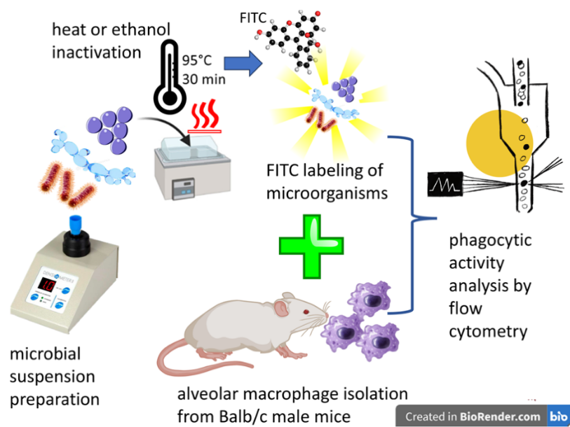

Fig.1. Study design

Statistical analysis. Data normality was evaluated using the Shapiro–Wilk test to ensure that the distribution of the measured variables met the assumptions required for parametric analysis (Mishra et al., 2019). All results are presented as the mean ± standard error of the mean (SEM). Statistical comparisons between experimental groups were carried out using a one-way ANOVA (Ntumi, 2021). When interpreting the outcomes, values of p < 0.05 were considered statistically significant.

Results
Analysis of phagocytic activity revealed clear differences in the AMs' ability to internalize the three tested microorganisms. The phagocytosis percentage was lowest for Escherichia coli, higher for Staphylococcus aureus, and the highest for Candida albicans (Fig. 2).

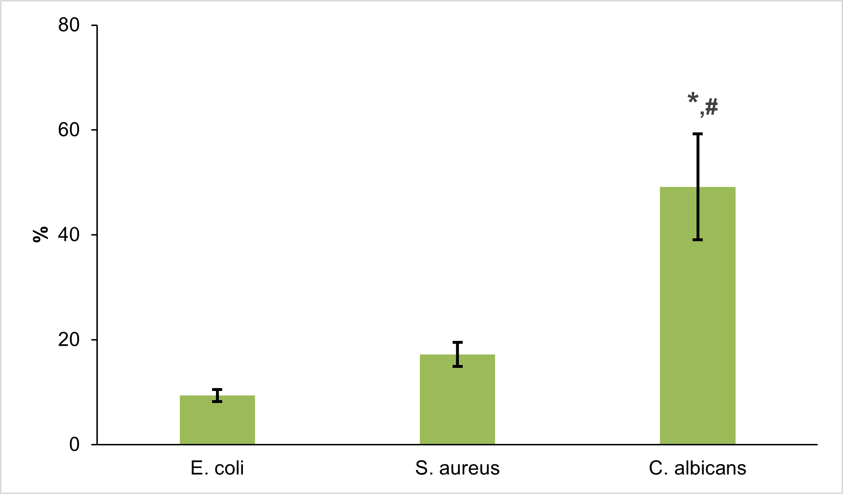
Fig. 2. Phagocytosis percentage of murine alveolar macrophages incubated with FITC-labeled E. coli, S. aureus, and C. albicans.
(n=3; *p < 0.01 compared with Escherichia coli; #p < 0.05 compared to Staphylococcus aureus)

A similar pattern was observed for the phagocytic index (MFI). AM incubated with both E. coli and S. aureus exhibited low MFI values. In contrast, in C. albicans, significantly higher fluorescence intensity was observed, indicating a substantially greater amount of internalized fungus per cell (Table 1).
Table 1
Lytic Activity Spectra of Psa 12 and Psa 60 Phage Isolates Against Various Strains of P. aeruginosa
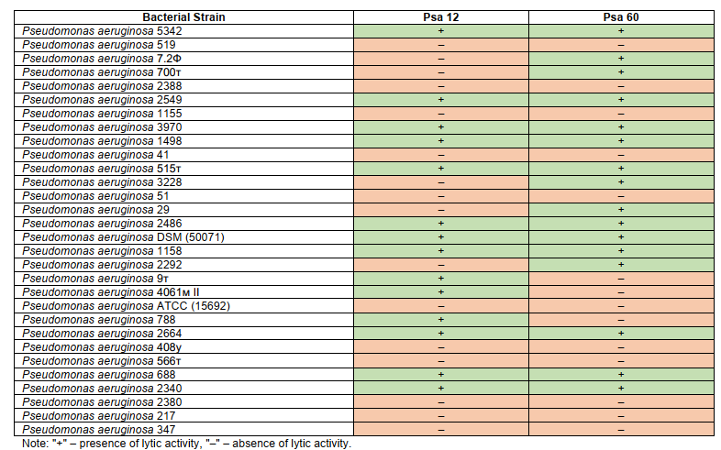

Discussion and conclusions
Bacteria employ multiple immune-evasion strategies that limit phagocytic clearance, including masking of pathogen-associated molecular patterns and opsonins by capsules, as well as interference with phagosome maturation and phagolysosome formation (Gao et al., 2024; Lee et al., 2020; Uribe-Querol & Rosales, 2017). By using inactivated microorganisms, the present study specifically assessed the intrinsic phagocytic capacity of alveolar macrophages, independent of active microbial evasion mechanisms.
Phagocytosis is initiated through the recognition of pathogen-associated molecular patterns by pattern recognition receptors expressed on macrophages, and differences in uptake efficiency likely reflect variations in receptor engagement (Mukhopadhyay, Plüddemann, & Gordon, 2009). Among these receptors, C-type lectin receptors (CLRs) play a central role in antifungal immunity. Macrophages express several CLRs, including Dectin-1, Dectin-2, the Mannose Receptor (CD206), and DC-SIGN, which efficiently recognize fungal cell wall components such as β-glucans and mannans (Patin, Thompson, & Orr, 2019). Signaling through Dectin-1 promotes phagocytosis, reactive oxygen species generation, cytokine release, inflammasome activation, and Th1/Th17 polarization (Geijtenbeek & Gringhuis, 2009; 2016).
Taken together, our results show that murine alveolar macrophages exhibit significantly higher phagocytic activity toward Candida albicans than toward Gram-positive or Gram-negative bacteria under non-opsonized, non-inflammatory conditions. This pattern is consistent with preferential engagement of fungal recognition pathways, particularly C-type lectin receptors, in resting alveolar macrophages. The comparatively low bacterial uptake in this model suggests that efficient antibacterial phagocytosis requires additional signals, such as inflammatory priming or opsonization. Overall, this study delineates pathogen-specific differences in phagocytic efficiency relevant to early innate pulmonary defense.

Authors' contribution: Sofia Suslova: investigation, writing – original draft; Nataliia Steniakina: investigation, writing – original draft; Roman Dovhyi: writing – review & editing; Tetiana Babich: formal analysis; Yuliia Yumyna: conceptualization.

Acknowledgements and Funding: The study was conducted within the framework of research-oriented laboratory classes of the course “Laboratory Practicum in Immunology” at Taras Shevchenko National University of Kyiv and received no external funding.

References
Arafa, E. I., Shenoy, A. T., Barker, K. A., Etesami, N. S., Martin, I. M., Lyon De Ana, C., Na, E., Odom, C. V., Goltry, W. N., Korkmaz, F. T., Wooten, A. K., Belkina, A. C., Guillon, A., Forsberg, E. C., Jones, M. R., Quinton, L. J., & Mizgerd, J. P. (2022). Recruitment and training of alveolar macrophages after pneumococcal pneumonia. JCI Insight, 7(5), e150239. https://doi.org/10.1172/jci.insight.150239
Arana, I. C., Añino, Y., Murillo, D., & Ramírez-Camejo, L. A. (2025). Nationwide epidemiology of candidiasis in Panama, 2010–2020. Scientific Reports, 15(1), 43223. https://doi.org/10.1038/s41598-025-27218-z
Denning, D. W. (2024). Global incidence and mortality of severe fungal disease. The Lancet Infectious Diseases, 24(7), e428–e438. https://doi.org/10.1016/S1473-3099(23)00692-8
Fan, C., Huang, X., Mei, J., Shi, X., Zhang, H., Liang, C., Cui, S., Xing, Y., Cao, B., Liu, W., Liu, H., Liu, B., Chang, W., Shao, M., Wei, G. H., Liu, Y. J., Chen, Z. J., Lin, Z., Xu, T., & Jiu, Y. (2025). Macrophages form dendrite-like pseudopods to enhance bacterial ingestion. The EMBO Journal, 44(17), 4772–4802. https://doi.org/10.1038/s44318-025-00515-z
Freundt, K., Herzmann, C., Biedziak, D., Scheffzük, C., Gaede, K. I., & Stamme, C. (2022). Surfactant protein A enhances the degradation of LPS-induced TLR4 in primary alveolar macrophages involving Rab7, β-arrestin2, and mTORC1. Infection and Immunity, 90(2), e00250-21. https://doi.org/10.1128/IAI.00250-21
Fu, Y., Gong, T., Loughran, P. A., Li, Y., Billiar, T. R., Liu, Y., Wen, Z., & Fan, J. (2025). Roles of TLR4 in macrophage immunity and macrophage–pulmonary vascular/lymphatic endothelial cell interactions in sepsis. Communications Biology, 8(1), 469. https://doi.org/10.1038/s42003-025-07921-3
Gao, S., Jin, W., Quan, Y., Li, Y., Shen, Y., Yuan, S., Yi, L., Wang, Y., & Wang, Y. (2024). Bacterial capsules: Occurrence, mechanism, and function. NPJ Biofilms and Microbiomes, 10(1), 21. https://doi.org/10.1038/s41522-024-00497-6
GBD 2021 Lower Respiratory Infections and Antimicrobial Resistance Collaborators. (2024). Global, regional, and national incidence and mortality burden of non-COVID-19 lower respiratory infections and aetiologies, 1990–2021: A systematic analysis from the Global Burden of Disease Study 2021. The Lancet Infectious Diseases, 24(9), 974–1002. https://doi.org/10.1016/S1473-3099(24)00176-2
Li, M., Liu, M., & Liu, J. (2025). Trends in the mortality, deaths, and aetiologies of lower respiratory infections among 204 countries from 1991 to 2021: An updated systematic study. Viruses, 17(7), 892. https://doi.org/10.3390/v17070892
Luckow, B., & Lehmann, M. H. (2021). A simplified method for bronchoalveolar lavage in mice by orotracheal intubation avoiding tracheotomy. BioTechniques, 71(4), 534–537. https://doi.org/10.2144/btn-2021-0022
Mass, E., Nimmerjahn, F., Kierdorf, K., & Schlitzer, A. (2023). Tissue-specific macrophages: How they develop and choreograph tissue biology. Nature Reviews Immunology, 23(9), 563–579. https://doi.org/10.1038/s41577-023-00848-y
Mukhopadhyay, S., Plüddemann, A., & Gordon, S. (2009). Macrophage pattern recognition receptors in immunity, homeostasis and self tolerance. Advances in Experimental Medicine and Biology, 653, 1–14. https://doi.org/10.1007/978-1-4419-0901-5_1
Ntumi, S. (2021). Reporting and interpreting one-way analysis of variance (ANOVA) using a data-driven example: A practical guide for social science researchers. Journal of Research in Educational Sciences, 12(14), 38–47. https://doi.org/10.14505/jres.v12.14.04
Panahipoor Javaherdehi, A., Ghanbari, S., Mahdavi, P., Zafarani, A., & Razizadeh, M. H. (2024). The role of alveolar macrophages in viral respiratory infections and their therapeutic implications. Biochemistry and Biophysics Reports, 40, 101826. https://doi.org/10.1016/j.bbrep.2024.101826

Отриманоредакцією журналу/Received:
Прорецензовано/Revised:
Схвалено до друку/Accepted:

Наталія СТЕНЯКІНА, студ.
Київський національний університет імені Тараса Шевченка
ORCID ID: 0009-0005-2419-8255
e-mail: steniakina_nataliia@knu.ua

Тетяна БАБІЧ, канд. біол. наук, асист.
Київський національний університет імені Тараса Шевченка
ORCID ID: 0000-0001-9500-6437
e-mail: babich_tetiana@knu.ua

Юлія ЮМИНА, канд. біол. наук, доц.
Київський національний університет імені Тараса Шевченка
ORCID ID: 0000-0002-4568-1415
e-mail: juliayumyna@knu.ua

МІКРООРГАНІЗМ-ЗАЛЕЖНА ФАГОЦИТАРНА АКТИВНІСТЬ АЛЬВЕОЛЯРНИХ МАКРОФАГІВ МИШЕЙ

Вступ. Макрофаги – це фенотипово та функціонально гетерогенні клітини, що відіграють ключову роль у реакціях вродженого та адаптивного імунітету. Альвеолярні макрофаги (AM) є основною популяцією резидентних імунних клітин у дистальних відділах дихальних шляхів і становлять першу лінію клітинного захисту від мікроорганізмів, що потрапляють у дихальні шляхи при вдиханні. Фагоцитоз є фундаментальною функцією AM, що забезпечує як видалення патогенів, так і підтримання гомеостазу легень. Проте ефективність, з якою AM поглинають різні класи мікроорганізмів, досі вивчена недостатньо, незважаючи на її значення для раннього розпізнавання патогенів у легенях. Метою цього дослідження було за допомогою проточної цитофлуориметрії кількісно порівняти фагоцитарну активність альвеолярних макрофагів мишей щодо грам-негативних бактерій (Escherichia coli), грам-позитивних бактерій (Staphylococcus aureus) та дріжджоподібного гриба Candida albicans в умовах in vitro без опсонізації та запальної стимуляції.
Методи. AM мишей лінії BALB/c були виділені шляхом отримання бронхоальвеолярного лаважу. Фагоцитарну активність оцінювали, використовуючи мічені FITC інактивовані мікроорганізми, зокрема інактивований нагріванням Staphylococcus aureus (грампозитивна бактерія), інактивована нагріванням Escherichia coli (грамнегативна бактерія) та інактивована спиртом Candida albicans. AM інкубували з мікроорганізмами 30 хвилин при 37 °C. Фагоцитоз кількісно оцінювали методом проточної цитометрії за відсотком FITC-позитивних клітин та фагоцитарним індексом, вираженим як середня інтенсивність флуоресценції.
Результати. Аналіз фагоцитарної активності AM показав виражену залежність від типу мікроорганізму. Найнижчий рівень поглинання спостерігався у Escherichia coli, проміжний – у Staphylococcus aureus, а найвищий – у Candida albicans. Така закономірність спостерігалася як для відсотка фагоцитуючих клітин, так і для фагоцитарного індексу.
Висновки. Підсумовуючи, в умовах in vitro без опсонізації та запальної стимуляції альвеолярні макрофаги мишей ефективніше фагоцитують Candida albicans, ніж грам-позитивні або грам-негативні бактерії. Ці результати підкреслюють відмінності у фагоцитарній активності альвеолярних макрофагів, що залежать від виду патогену та мають значення для раннього вродженого імунного захисту легень.
Ключові слова: альвеолярні макрофаги, фагоцитарна активність, Staphylococcus aureus, Escherichia coli, Candida albicans.

Автори заявляють про відсутність конфлікту інтересів. Спонсори не брали участі в розробленні дослідження; у зборі, аналізі чи інтерпретації даних; у написанні рукопису; в рішенні про публікацію результатів.
The authors declare no conflicts of interest. The funders had no role in the design of the study, the collection, analysis, or interpretation of data, the writing of the manuscript, or the decision to publish the results.

